Tests performed 2/28/2025 RJHegler scans witnessed by Jeff Shandor

EMI testing performed using a HP Spectrum Analyzer:

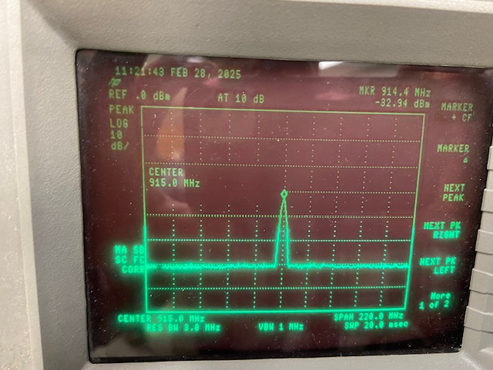
LoRa send and response from PostAlert: near field magnetic probe

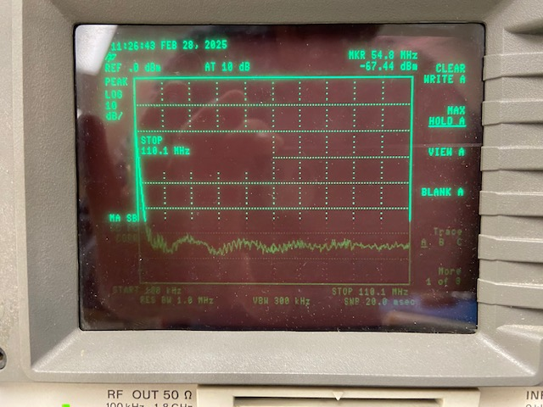
Magnetic field probe placed near the OLED display of the base unit.

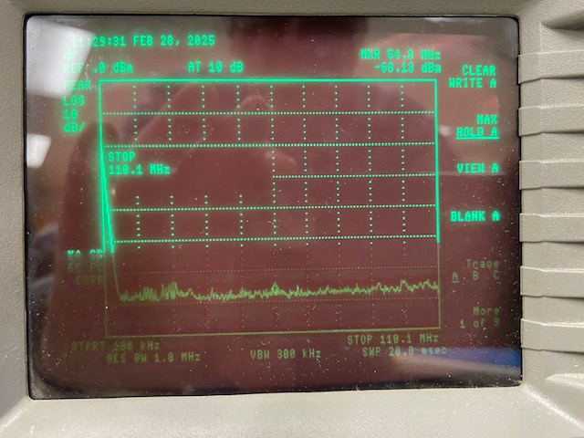
E-field probe placed near the OLED display of the base unit.

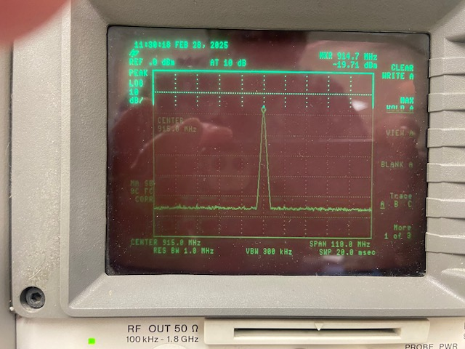
E-Field probe showing LoRa send and response.

